Statistics Assignment 4 - John Sinclair - 16325734

Q1.

1. {(1,1)}

There is only one event where Y = 2, when both dice roll a 1

1. {(1,2), (2,1)}

There are two events in which Y = 3, when dice A rolls a 1 and dice B rolls a 2, and when dice A rolls a 2 and dice B a 1

1. {(1,3), (2,2), (3,1)}

There are three possible events where Y = 4, when dice A rolls a 1, dice B a 3, or when both dice roll a 2 or when dice A rolls a 3 and dice B a 1

1. (1 / 36) + (1 / 36) + (1 / 36) = 0.083

For each of the three outcomes in the sample space we are choosing one outcome of a possible 36 (6 options x 6 options), therefore it is 1 / 36 for each element in the sample space, we add these probabilities up to get the probability of the entire sample space

Q2.

1. X = {-3, -1, 1, 3}

Possible outcomes:

HHH = 3

HHT = 1

HTH = 1

HTT = -1

THH = 1

THT = -1

TTH = -1

TTT = -3

1. 2 x 2 x 2 = 8, 1 / 8 = 0.125

From the above outcome table we can see only one of the eight possible outcomes results in a -3, therefore 1 / 8

1. 2 x 2 x 2 = 8, 3 / 8 = 0.375

From the outcome table above we can see X = -1 three times out of the possible eight outcomes, therefore 3 / 8

1. PMF

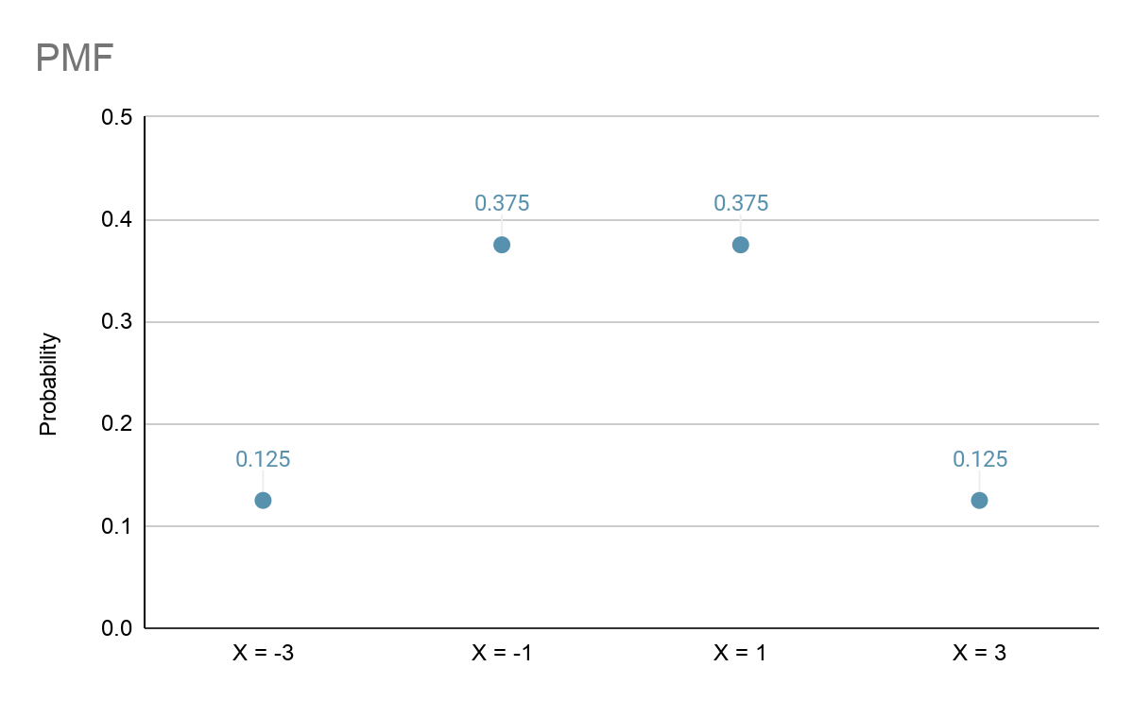

Q3.

1. 1

The probability that the minimum value of four six-sided dice rolls is greater or equal to one is 1 as the minimum value the dice can produce is a one, therefore X will always greater or equal to 1

1. (5 / 6)4

For the minimum value of the four dice rolled to be greater or equal to 2 we essentially eliminate 1 as a possible resulting value, therefore we have 5 options of a posible 6, therefore 5 / 6 for each roll. Four dice are rolled so this probability is multiplied by itself 4 times